EX NO:1 Butterworth IIR Filters
  - Design and Analysis of a Butterworth IIR Low-Pass Filter Using MATLAB.
Objective 1:
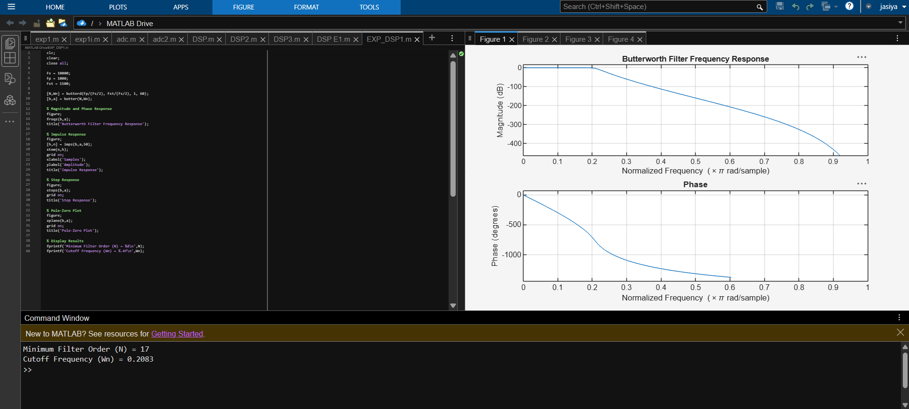
Objective 2:
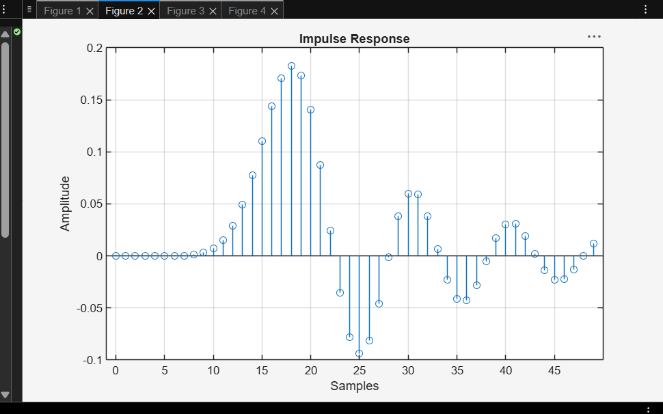
Objective 3:
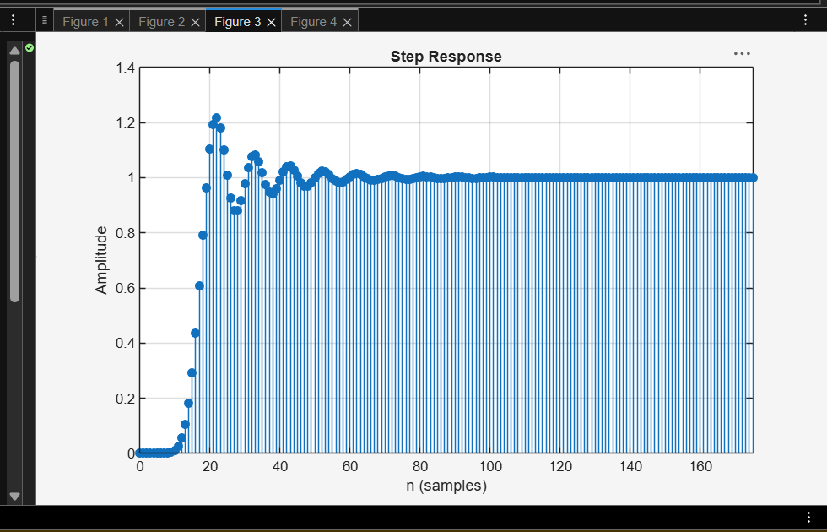

Objective 4:
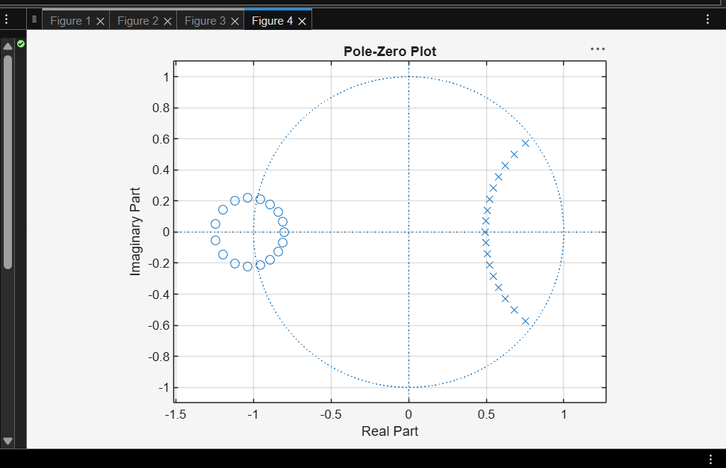
Result:
1.The minimum filter order and cutoff frequency satisfying the given specifications were determined successfully.
2.The magnitude and phase responses of the Butterworth IIR low-pass filter were obtained and analyzed.
3.The impulse response, step response, and group delay characteristics were evaluated successfully.
4. The pole-zero plot confirmed the stability and proper performance of the designed filter.
EX NO:1 | Butterworth IIR Filters
 | 1.2. Design and Analysis of a Butterworth IIR High-Pass Filter Using MATLAB.

Objective 1:
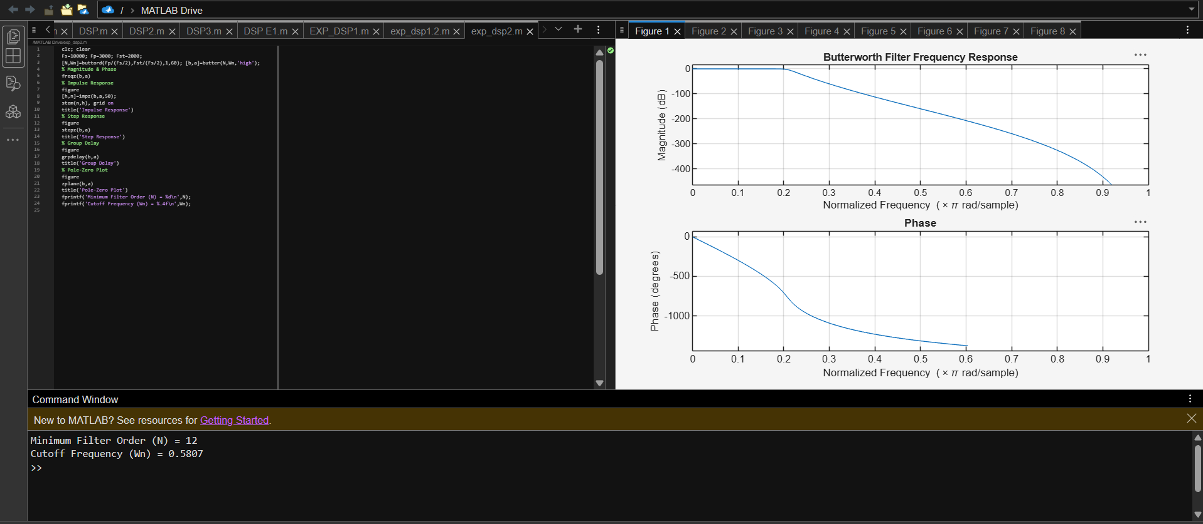
Objective2:
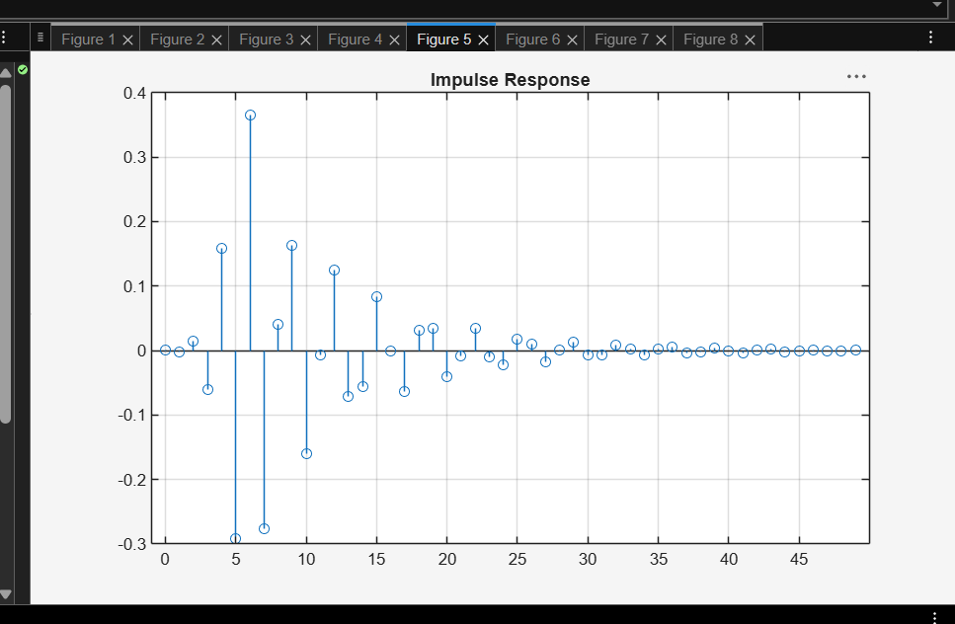
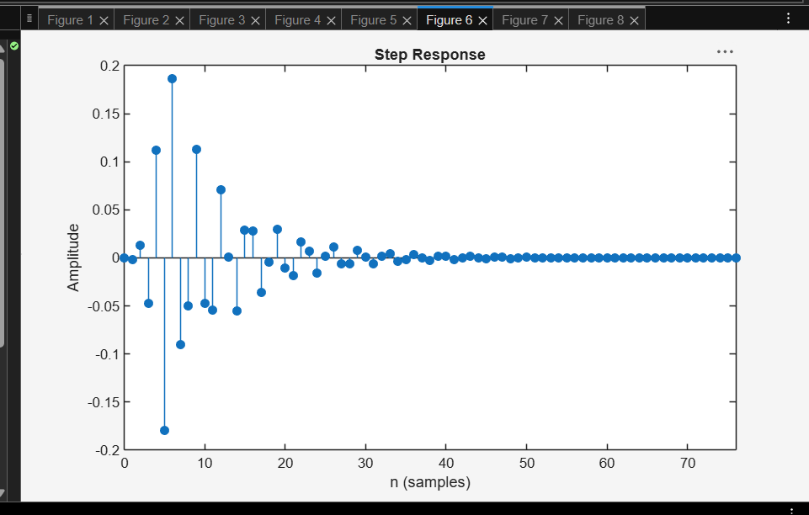
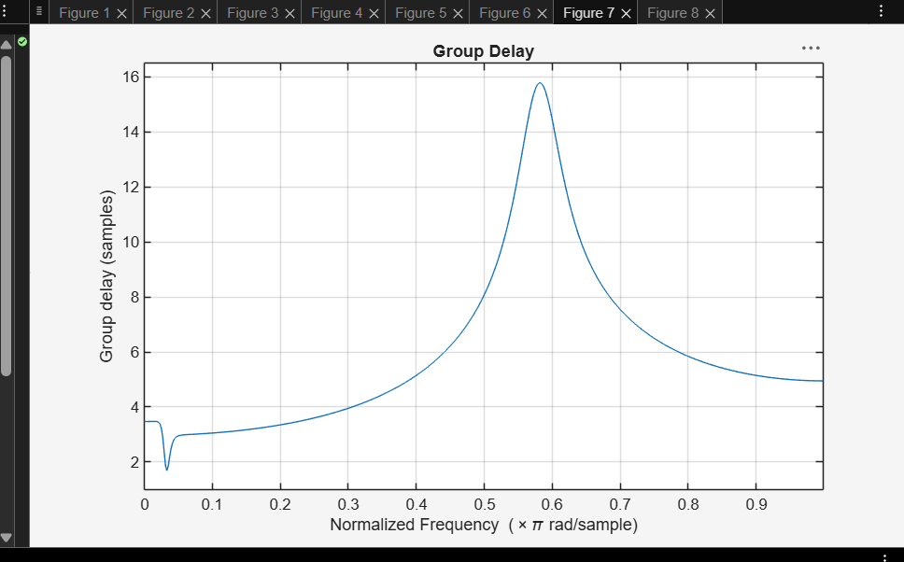
Objective3:
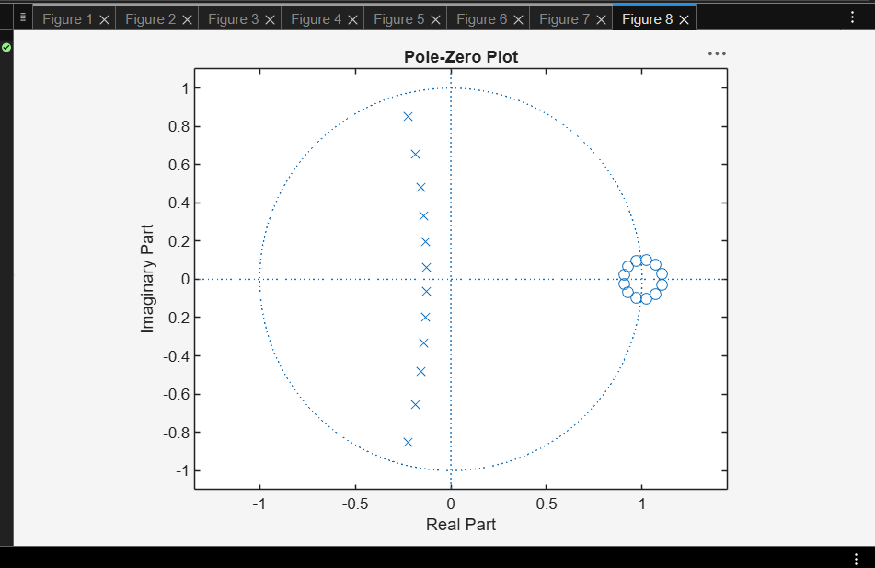

Result:
1.The minimum filter order and cutoff frequency satisfying the given specifications were determined successfully.
2.The magnitude and phase responses of the Butterworth IIR High-pass filter were obtained and analyzed.
3.The impulse response, step response, and group delay characteristics were evaluated successfully.
4. The pole-zero plot confirmed the stability and proper performance of the designed filter.

